Special Educational Needs and Disabilities at
St. William’s Catholic Primary School
Welcome to our SEN Information Report which is part of the Bradford Local Offer for learners with Special Needs & Disability (SEND).
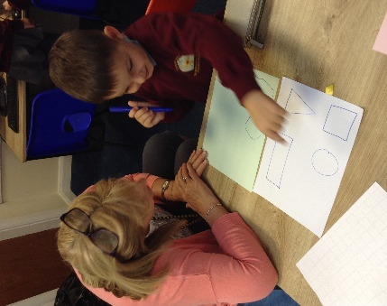
At St William’s Catholic Primary School, we believe passionately in the importance of inclusion and equality for all children and adults. We strive to ensure that these values are at the heart of our SEND practices.
We will always involve parents and children in key decisions, as well as planning and reviewing progress; we know that parents are the first educators of their child and that we need their knowledge and co-operation to plan effectively.
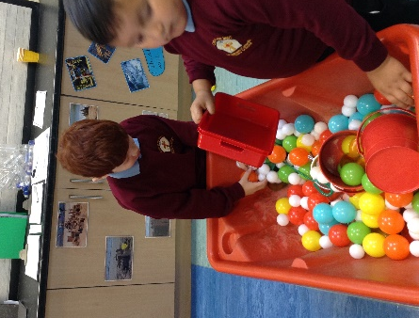
We know that the earlier we identify SEND and provide support, the more successful our children will be.
We are committed to providing expert support and resources for children with SEND to fulfil their individual potential.
Our starting point is to guarantee a whole -school approach to providing for the needs of children with SEND. In other words, we make sure that all staff have the knowledge and skills to support all children, throughout our school. We work in partnership with external professionals to support bespoke provision.
Who can help you at St William's?
The best people to contact if you have any queries with regard to SEND provision at St William’s are:
Head teacher – Fiona Parker
SENDCO and senior leader for mental health – Fiona Parker
SEND Governor – Andrea Pritchard
These can all be contacted by e-mailing office@wil.bcwcat.co.uk or telephone school on 01274 545743

What are Special Educational Needs?
A special educational need can be a number of different things. For example, your child may be having problems with reading, maths or behaviour, which school can help by putting extra support in at school and by working in partnership with yourself.
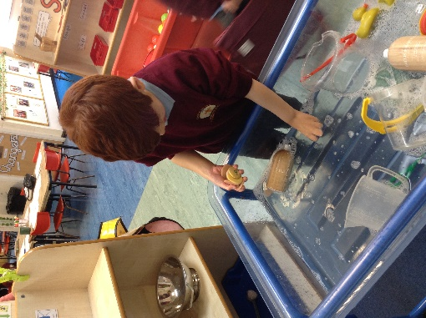
It may also be due to a disability which makes it harder for a child to use the same educational facilities that the school provides for the majority of children. For some children this may be a temporary difficulty, while others may have a long term need for special help.
There are four broad areas of need:
- Cognition and learning
- Communication and Interactions
- Physical and or sensory
- Social, Emotional and Mental Health

Firstly, children learn and develop in different ways. if you have any concerns about your child, please speak to the class teacher. The class teacher can then pass on any information to the relevant members of staff.

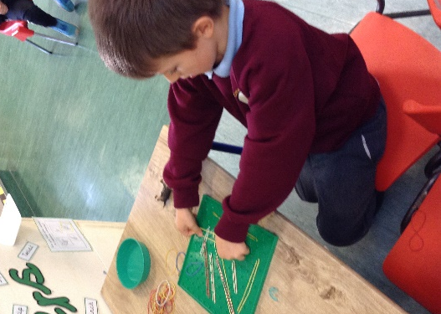
How do schools help children with Special Educational Needs?
Children are all unique and develop and learn at different paces and in different ways. At St William’s, the teachers recognise this and use different teaching styles, resources and plan different levels of work in the classroom to cater for the various ways children learn.
This is called Quality First Teaching and is something schools must provide for all children. However, many children, at some time in their school life, need extra help.

Because of this, schools must:
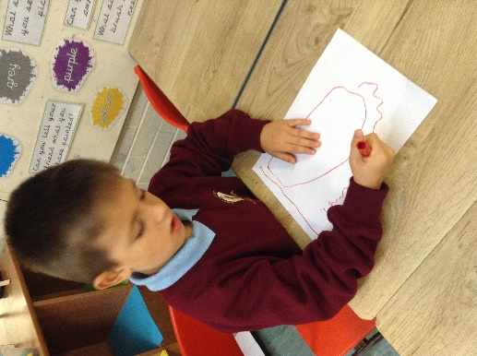
- Talk to parents/carers if they think their child has a special educational need and let them know what special help the school is giving
- Appoint a member of staff as the Special Educational Needs and Disabilities Co-ordinator (SENCO)
- Have a written Special Educational Needs policy – a copy should be made available for parents.
- Take account of the Special Educational Needs (SEN) Code of Practice. (This is advice given to schools by the government which outlines what schools should do to support pupils with SEN and gives recommendations for good practice).

To find out more about special needs at St William's, click on the downloadable document above.

The Local Offer service for SEND children and young adults.
The new Local Offer website has been launched. The website provides information, help and support for children and young adults with Special Educational Needs and/or Disabilities and their families. Visit https://localoffer.bradford.gov.uk/
The Local Offer makes it easier to find out what a young person, parent, carer or service provider needs to know, when they need to know it. It tells them where the nearest and most suitable services are as well as links to organisations, activities and things to do in the Bradford area.

If you have any other questions please contact school and we will help in any way we can!

