St. William’s Music Development Plan 
Date of adoption: September 2026
Review: July 2027
Lead for this plan: Fiona Parker handing to Michala Balsham

Links:
The Power of Music to Change Lives – the National Plan for Music Education in England 2022-2030 https://www.gov.uk/government/publications/the-power-of-music-to-change-lives-a-national-plan-for-music-education
Music Mark’s resource page for the English National Plan for Music Education https://www.musicmark.org.uk/all-resources/

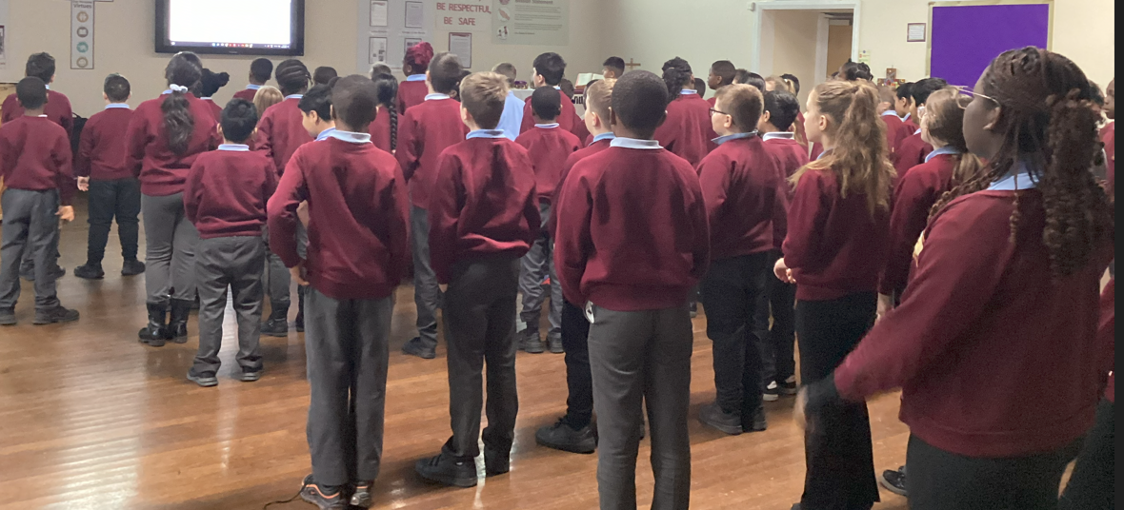
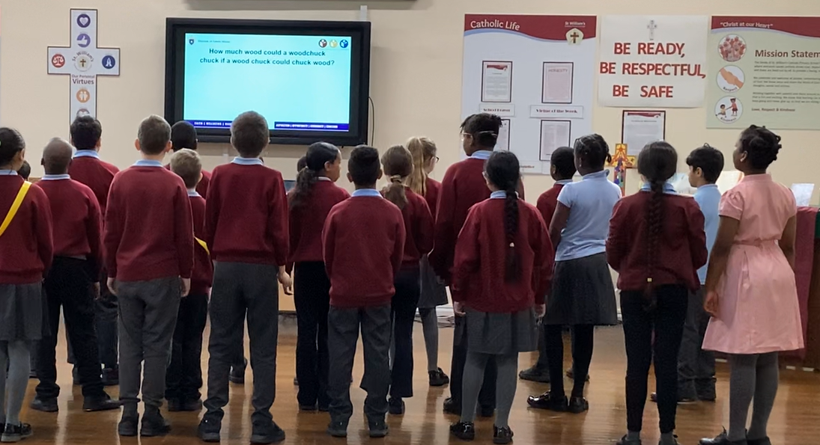
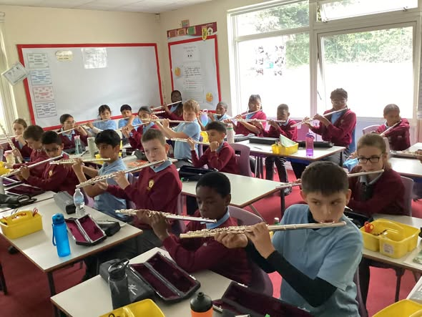

Music in the classroom
area | what happens now | what we would like to see | link to actions
Overview | St. William’s implements the National Curriculum for Music and uses Sing Up Music Scheme (see school website for EYFS, KS1 & KS2 intent, progression documents), as part of St. William’s drawing closer to the Model Music Curriculum.  All pupils continue to receive 1 hour per week for Music.  Class teachers deliver this Music Curriculum and specialist music teachers deliver whole class Singing lessons weekly to 2 KS2 classes. There are whole class, specialist musical instrumental lessons for Years 4, 5 and 6 lessons.  Digital resources  This includes whole class recorders glockenspiels in school as well as a variety of other tuned and untuned musical instruments in school.  Flute tuition provided by Bradford Music & Arts Service  Music is assessed termly by class teachers against the objectives taught (Recording before/after)  The impact of the Music curriculum enhances character education, developing the whole person and ‘’Music is an essential part of a broad & ambitious curriculum for all pupils…[and] we want to see more children and young people supported to navigate the many exciting opportunities to progress music beyond their core school provision’’ (National Plan for Music 2022). Music is contributing to the school improvement, impacting positively on academic attainment and pupil wellbeing. Art and Music are a significant part of RE Teaching as well as opportunities to enhance spiritual growth. | Music is a consistent and valued part of the curriculum. The strong Music delivery provides at least 1 hour of Music, for all pupils using the Model Music Curriculum.  All pupils will have opportunities to:  - Perform, listen to review & evaluate a range of different music.  - Learn to sing and use their voices.  - Create and compose music on their own and with others.  - Can learn a musical instrument and use technology appropriately.  - Progress to the next level of musical excellence  - Understand and explore how music is created, produced, and communicated.  - Provision is inclusive and diverse (values all musical styles).  - DV pupils are given support to engage in music learning as part of the curriculum. Vulnerable pupils and those with SEND can participate and progress.  - Pupils showcase their work and experience performance as part of their ongoing learning.  - Pupils make good progress by securing incremental learning of technical skills in playing, singing, composing, and listening to music.  - The depth, breadth and quality of pupils’ musical responses continue to develop.  - High – quality music education enables lifelong participation in and enjoyment of music. | MB & AJ M & E activities ongoing throughout school year.  Class teachers’ delivery the high-quality music learning, using Sing Up Scheme effectively.  Maintain high priority to engage all pupils, including Vul, DV & those with SEND.  The school provides musical opportunities that they would not otherwise have access to.
Whole Class Ensemble Tuition | Specialist teacher (weekly lessons of 30 mins or 40 mins per class) for Flutes in Years 4, 5 & 6 from the Bradford Music & Arts | Continuing to develop the current musical culture with the weekly delivery of instrumental class lessons in Lime & Holly Classes.  Music & Art Leaders continue to collaborate with all teaching staff to continue working towards Artsmark Award following the 1st year of this 2025-26.  Pupils will develop specific skills and confidence to continue to learn how to play the flute, encouraging them to continue this learning at secondary school. | Music Leader to seek to access this from Music Hub
Singing | Specialist Singing teacher for Lime and Holly Classes (years 4, 5 and 6) from Leeds Diocese Music Services.  Whole school singing during Celebration of the Word and seasonal concerts/events e.g. Harvest Festival, Nativity, Holy Week Liturgies and end of year performance for parents from upper KS2 pupils summer term. | Continuing to develop the current musical culture with the weekly delivery of vocal class lessons in Lime and Holly Classes to promote their singing skills and enjoyment for singing, supporting active participation in opportunities to sing outside these lessons.  Opportunities for pupils to participate in Junior and Senior Leeds Diocesan Choirs and the BCWCAT Autumn Concert at SBSJs. | SLT & Music Leader developing the music culture and enriching curriculum offer.
Instrumental music | Adaptation of teaching to meet the needs and close gaps. Review of progress ongoing and then termly to inform future teaching (scheme of work for the year specific to their teaching). | See planning and assessment from Recorder or Flute and Singing teachers.  Instrumental teaching to support the teaching of music by class teachers using the Sing Up Scheme. | Specific planning and assessment from Flute specialist teacher and Singing Leeds Diocesan Teachers
Technology | Music tech as a learning resource in class  Teachers assess the musical units for each half term, and these inform termly assessments.  A range of resources, including instruments are available. | Pupils use electronic devices to support their learning in Music as well as for assessing progress (before and after teaching). Children view recordings of themselves to improve upon next time. | See videos shared on twitter/website and class records.
Opportunities to experience live music performance | Children hear live music performed (e.g., by other children, teachers, amateur adults, professionals) as organised by Music Subject Leader for whole school activities and as part of teachers’ class teaching. | During the academic year pupils can hear live music (Bradford Music & Arts Services Orchestra) and participate in workshops e.g., Samba Bamba Bash Your Drum. These are funded from both pupil premium & music budget | Music Leader, RE & RSE to develop cultural capital opportunities.

Extra-curricular and Co-curricular Music
area | what happens now | what we would like to see | link to actions
Overview | All pupils are encouraged to join the school choir and there is no charge for any Music lesson or Choir club.  Music Leader actively seeks parents to consent to taking their child to join and participate in the Bradford Choir led by Leeds Diocese Singing teachers. | Imani Hamilton leads school choir in school, and she regularly attends Music Hub training.  Imani Hamilton Art & Music Leader, last year to completed Artsmark training with Goldsmiths Autumn 1 2025 and complete the Statement of Commitment by Spring 1 2026 and using the Statement of Impact by Summer 1 2026. Specific actions are in place for 2026-27  Leeds Diocesan Singing teachers, lead the Diocesan senior and junior choirs. | Opportunities for pupils to perform and participate to wider audiences at Diocesan and BCWCAT Trust concerts.
Singing | All pupils are actively encouraged to participate in singing during assemblies and liturgies, linked to the liturgical season, using backing tracks or live music.  SLT & RE leader leads these. Weekly choir club in the school hall. St. William’s School participates in Trust Art & Music events and concerts. | Continue to encourage more pupils to sing in a variety of ways, especially upper KS2 pupils and particularly more boys – asking them personally to participate in choir, performances for the BCWCAT. Feedback from pupils and parents are positive and specific pupils are targeted to participate as well an open invitation to all pupils. | Numbers increase and there is a balance of boys & girls and older and younger pupils.
Ensembles | To develop ensembles performing short pieces during assemblies and liturgies, show casing skills and knowledge they have learned during music/singing lessons. | Pupils confidently apply the skills they have been learning to enhance liturgical celebrations/worship and whole school singing/music. | Strengthen links to music hub and increasing performance opportunities.
Tuition | N/A – St. William’s School provides specialist music lessons to ensure all pupils, especially DV/Vul/SEND have same opportunity. | Whole class teaching rather than tuition to provide inclusive music education. | All pupils receive the same opportunity because this is provided by school and not reliant on parents/carers paying for private lessons.

Leadership
area | what happens now | what we would like to see | link to actions
Governing body | Lead Governor for Music  How they fulfil their leadership role | Agiya Janson continuing to participate in a range of M & E activities during the year and meeting with Music Subject Leader, Michala Balsham. | Strengthening leadership.
Senior Leadership Team | How SLT project the place/role of Music in school  Understanding of Music as a curriculum area  Understanding of extra- and co-curricular music  Assessment frameworks | See St. William’s Curriculum Offer on school website & SDP 2026-27  Working towards the Artsmark Award with teaching staff – see Autumn 2026-July 2027 actions.
Subject leadership | Michala Balsham Music Subject Leader monitors the delivery (see M & E schedules) and identifies CPD needs, allocating these accordingly.  Implementing National Curriculum Model Music Curriculum – see Music Intent, Implementation & Outcome. | Music Leader CPD informing next steps and regularly CPD for all teachers delivering music – through staff feedback identifying training gaps to close. Following the New Model Curriculum and Sing Up training to implement teaching and learning music.

Budget
area | what happens now | what we would like to see | link to actions
Budget for Music | 2026/27 Budget  Flutes teaching & instrument hire  £2424  Sing Up – part of Bradford offer | Additional expenditure for concerts, CDs, purchase of performances e.g., Nativity, Holy Week/Lent and specific e.g., y6 end of year performance.
Music income | No ticket charges to parents  Top up from pupil premium funding | Allocated Music budget from within the school budget and some pupil premium funding. | Commitment for all pupils and parents/carers to have the same access.

Partnerships
area | what happens now | what we would like to see | link to actions
Partnerships with schools | Music Leader and other staff regularly participate in Bradford & Arts Services Network Meetings and training – keeping updated on national and local events/curriculum. | Music Hub Links/ further developing our participation in Trust events for concerts and network CPD.
Partnership or relationship with local music service or Music Education Hub | Currently enjoy positive close links with Bradford Music and Arts Services with KS2 pupils from St. William’s performing with Halle Orchestra and LKS2 pupils participating in Sing Low in last few years and the Bradford Live Record-Breaking Event Autumn 2025. | To continue to work closely work with the Music Hub and access all they can offer.
Cultural partners for music | Partners you work with (e.g., musicians, groups, music charities, national organisations)  What they do and the value they bring  How activity is funded | Continue to provide opportunities for musicians/dancers to come into school to work with classes to enhance children’s personal development. Music & Art Leaders to begin Artsmark work for St. William’s in this year (to achieve in 1 year’s time) .

Accommodation and resources
area | what happens now | what we would like to see | link to actions
Spaces for Music | Music is taught in classrooms.  Choir takes place in hall/or classroom.  Where instrumental/vocal tuition happens in the hall. | Maintain these areas.
Resources available for Music | 30 recorders, 30 glockenspiels the school owns. A range of wind, percussion instruments, both tuned and untuned instruments.  (See previous budget) | Increase in whole class instruments to ensure that the curriculum can be delivered and broadens pupils’ musical learning and experiences so all KS2 pupils receive specialist instrumental tuition and KS1 class receive specialist singing teaching termly and throughout the year.

Inclusion
area | what happens now | what we would like to see | link to actions
Overview | The curriculum is accessible for all learners, including those with SEND by support from class teacher.  Learners are exposed to music from cultures other than their own and/or not represented in the school.  No interventions for other subjects routinely take place during Music lessons or whole school collective worship. | Maintenance of the curriculum offer for all – priority given to most vulnerable, DV & SEND pupils to ensure that they receive a range of musical opportunities and learning that they would not otherwise receive.
Special Educational Needs and Disabilities | Children with SEND are assessed to enable them to participate in music-making, this might be through practical resources and or additional adult support to help pupils’ close gaps and achieve. | Maintenance of provision for pupils with SEND. | St. William’s SEND offer & Mental Health and Wellbeing of pupils.
Religion | Termly curriculum newsletters for each class inform parents of what children will learn and the weekly newsletter celebrates learning – see X, formerly twitter, class dojo & school website for videos of performances as well as parents visiting lessons by specialist teachers during the academic year to show progress. | Maintain this to inform and celebrate musical performances and learning. The Leeds Diocesan Singing teaching enhances liturgical celebrations and supports teaching of the different parts of the Mass and the specifics of each liturgical season.
Financial hardship | A portion of Pupil Premium is used for Music to ensure all pupils, especially DV/Vuln & SEND have rich musical learning, not for lessons, but transportation covered for concerts.  The school must provide and pay for families – parents are not able to pay and often struggle to make a reasonable contribution e.g., Young Voices | St. William’s to continue to pay for much of the Music provision. | All KS2 pupils have flute lessons. Diocesan Singing Programme for Lime and Holly Classes.

Progression
area | what happens now | what we would like to see | link to actions
Overview | Pupils receive specialist teaching for flutes and singing for a minimum of 2 and up to 4 years, for musical instrumental learning, to provide them with a real opportunity to develop skills and foster a love/enjoyment for music/singing.  Additional musical events are planned to enrich these experiences, and the music taught in class.  Planned music learning is sequential and available on the school website, using the progressive scheme Sing Up.  St. William’s provides excellence in learning as well as a strong Mental Health and Wellbeing Strategy, providing the highest standards of provision for all pupils and Music, especially Singing and the Arts are part of this. | Maintain the specialist teachers for flutes and singing follow specific plans to delivery this teaching and learning and progression is evident in the performances from the start and during the year. The school calendar shows additional events e.g., Samba Bamba Bash Your Drum, visits from orchestra etc. Sing Up supports the teaching of Music for non-specialist teachers (this is why these schemes were chosen for their progressive and ambitious teaching and learning opportunities. Pupils are assessed against specific objectives and teachers/pupils are developing recording to evidence progression and self/peer evaluation to improve Music.
Progression opportunities | St. William’s School signposts local opportunities to its pupils (e.g., ensembles run by the music service or Hub), see newsletters/notices to parents on class dojo.  Pupils are actively encouraged to participate in Musical events e.g. 67 ks2 pupils from St. William’s School with other pupils across the Bradford District with the Halle Orchestra at St. George’s Hall, Swing Low and further BCWCAT Trust events for the Arts e.g. Autumn Concert at SBSJs and Leeds Diocesan Musical events in Senior and Junior Choirs. Transition from y6 to y7 allows the high school to know strengths and opportunities that have been available to pupils here. | To continue to build upon these successful experiences and continue to work at improving parental engagement so that pupil numbers increase.
Pupil tracking | The school tracks musical progression in and out of the classroom termly. | Termly assessment to Music Leader.  Records of participation in musical events, concerts/choirs.
Strategy development | This strategy is monitored and reviewed termly by Music Subject Leader and Governor for Music to inform further development areas and celebrate strengths of the Music learning at St. William’s. | MB & AJ report to LAC Spring 2026.

Objectives 2025/26
- To continue instrumental music lessons to all of KS2 pupils to support their continuation of learning the flute beyond these lessons and at secondary school.
- To ensure that every pupil participates in at least one performance every half term (other pupils, parents, parish, governors)
- St. William’s to further engage in Music Hub Support, Music Leaders’ Network Meetings & to continue ensembles in school.
- To increase the number of pupil participation in school choir (to ensure all phases are represented and all groups of pupils DV/Vul, SEND) and a balance of girls and boys and for increased participation in Trust, local and national events by July 2026 in comparison to previous year.

Action Plan
Actions here should mostly contribute to your objectives for the year and, of course, there may be more than one action needed to achieve one objective (or one action may contribute to several objectives). If there are actions to do with ongoing running of curricular or co-curricular Music that you want to capture here, even if they do not contribute to objectives, then do so of course.

 | action | link to objective | who | resources or cost | source | music hub support sought | complete by
1 | Maintain strong contact Music Service to ensure instrumental teaching is consistently high for all KS2 pupils | 1 | Music Co-ordinator | See previous comments | English Hub or Music and Art Service | [Music Service] percussion tutor to lead | From Sept 25 to continue instrumental specialist teaching for all KS2 pupils.
2 | To ensure that every pupil participates in at least one performance every half term (other pupils, parents, parish, governors) |  | Music Leader in collaboration with teachers | No cost | n/a | n/a | Ongoing
3 | St. William’s pupils to have more ensemble sharing music learning to an audience. |  | Music Leader with support of Music Hub | TBC | Music Hub | n/a | July 2026
4 | To continue to increase the number of pupil participation in school choir (to ensure all phases are represented and all groups of pupils DV/Vul, SEND) and a balance of girls and boys, with St. William’s representatives participating in various concerts at Trust/LA level. |  | IH/FP | N/A | N/A | N/A | Summer 26
5

Timeline (live and subject to change)
Date | Title or Type | Channel | Subject | Owner / Contributor
01/09/25  05/09 | Website update  13/09 Education Sunday  Music Hub Orchestra whole school concert | Website | Upload revised intent, implementation & outcome – Music LTP  Staff, parents, pupils & families attend Mass – parish choir lead music | DHT
08/09/25 | Flutes lessons to start in school for KS2 pupils  Singing lessons to continue in school for Lime and Holly Classes.  17/09/24 Whole School Mass for this academic year and subsequent class and parish masses throughout the year.  Mental Wellbeing Day – music to make you feel…. | Newsletter  Staff bulletin  Assembly  E-mail  Social media | Promote and celebrate the starting point.  Feast days and liturgical celebrations, including Class and parish Masses (see APOP 2025-26) | Specialist teachers  Year 2 & KS2 pupils & staff
13/09/25  17/09/24 | Whole school family Mass  Y2 -Y6 Class Mass | St. William’s Church  St. William’s Church | Education Sunday | Parish choir  Christina Low & Carl White
30/09 | Lime Class Mass
01/10/25  03/10/25  October | Official opening of Prayer Gardens  Whole school Harvest Festival  Music Leaders’ Network Meeting  Black History Month – focus on composers/musicians following  20/10/25 Sing Low, Big Sing Beech Class | St. William’s School  School hall 2:40pm  2:30-4pm | Mary & St. Theresa of Lisieux  Food donations to St. Patrick’s Mission  Bradford Arts/ Music Service | Carl White
07/10 | Our Lady of the Rosary Beech Mass  World Mental Health Day & Trust Emotional Day | Parents attend  tbc | Pupils, parents and staff
20/10/25  21/10/25 | Class performances to parents and or another class  Whole school Presentation of Blessed Mary & CAFOD Jubilee Year of Hope Day | Celebrate learning ½ term  St. William’s Church | Specific units taught – including recorders, flutes and singing | Each class
27/10/25 | **half-term
11/11/24 | Holly Class Mass & Remembrance Service in school | St. William’s Church
18/11/25 | Lime Class Mass Dedication Basilica SS Peter & Paul
23/11/25 | School Family Mass @ St. William’s Church Christ the King |  | Christ the King
28/11/25 | Blessing of the Advent Wreaths | Celebration in school
15/12/25  16/12/25  19/12/25 | EYFS & KS1 Christmas Nativity Concert and KS2 Carol Service in church  Festive Sing Song | Website | Celebration of end-of-term performances and Christmas events
 | Christmas holiday 22/12-02/01/26
06/01/26 | Epiphany y2 -y6
13/01/26 | Holly Class Mass
20/01/26 | Lime Class Mass St. Sebastian
24/01/26 | School Family Mass 3rd Sun in Ord Time A | In church
27/01/26 | Lime Class
03/02/26 | Feast of St. Blaise KS2 Mass
 | 16th-20th Feb half term 18/02/26 Ash Wed
24/02/26 | KS2 Mass St. Matthias | In church
03/03/26 | Lime Class
15/03/26 | School Family Mass Mothering Sunday | In church
17/03 | Beech Class Mass St. Patrick’s Day | In church
24/03 | Holly Class Mass Oscar Romero
30/03-02/04/26 | Holy Week Liturgies in school
 | Easter holiday 3rd Apr-13th April
14/04/26 | Holly Class Mass
21/4/26 | Lime Class Mass
28/4 | Beech Class Mass
09/05/26 | School Family Mass
13/05 | May Procession Our Lady of Fatima
19/05/26 | Y2-y6 Mass
 | 23/24/05 Pentecost Sunday holiday 25/05-08/06/26
07/06/26 | Corpus Christi FHC Mass
08/06/25 | St. William of York Feast Day in school
09/06/26 | Holly Class Mass
12/06 | Feast Day of Most Sacred Heart of Jesus
16/06/26 | Lime Class
20/06/25 | School Family
23/06 | Beech Class Mass
13/07 | UKS2 End of Year Performance
14/07/26 | End of Year Mass
 | 17/07/26 school closes

CPD Plan
See questions and prompts on page 2 of the instructions to help you think about these. Again, the first item, shaded grey, is an example.
requirement | who | link to objective or action plan | how provided | Provider  (if relevant) | cost | when
Curriculum | Music Leader & Link governor for Music | Music curricula offer | CPD for Governors (virtual Teams) | Bradford Art & Music Services
 | Music Leader | As above | Music Network | As above | Nil | Each term
 | All staff |  | Face to face PDM for all teachers & HLTA |  |  | Autumn 2 2025
 | Music Leader | Music Leaders’ Network Meeting | Face to face meeting | Bradford Art & Music Services | nil | Spring 2025
 | HLTA Music | Network Meeting | Face to face meeting | Bradford Art & Music Services | nil | tbc
 |  |  |  | l | nil
 | Teacher Leading School Choir | Network Meeting | Face to face meeting | Bradford Art & Music Services | nil | tbc

Evaluation and progress tracking
We will know that this plan is working if participation and standards in music are maintained and developed further.

Progress updates
 | Autumn 1 | Autumn 2 | Spring 1 | Spring 2 | Summer 1 | Summer 2
Action 1 | Extend flute lessons to Year 5 in Lime Class.  Years 3 and 4 Beech Class perform to parents. | Years 4 and 5 Lime Class play the flute to accompany singing in assembly.  Ensembles perform in Carol Service or Nativity. | Extend flute lessons to Year 5 in Holly Class and a performance to another class. | All 3-year y3, 4 & 5Action groups perform flutes to Rec, Y1, Y2 & Y6. | Pupils leading music in liturgies/assemblies, verbally appraising performances to improve further next time. | Pupils leading music in liturgies/assemblies
Action 2 | To ensure that every pupil participates in at least one performance every half term (other pupils, parents, parish, governors) | To ensure that every pupil participates in at least one performance every half term (other pupils, parents, parish, governors | To ensure that every pupil participates in at least one performance every half term (other pupils, parents, parish, governors | To ensure that every pupil participates in at least one performance every half term (other pupils, parents, parish, governors | To ensure that every pupil participates in at least one performance every half term (other pupils, parents, parish, governors | To ensure that every pupil participates in at least one performance every half term (other pupils, parents, parish, governors
Action 3 | St. William’s pupils to have more ensemble sharing music learning to an audience. Start with Y2 glockenspiel performance. | Ensemble of recorders performing Nativity. | Ensemble of flutes and glockenspiels perform to pupils in assembly. | Ensemble of flutes performing Holy Week Liturgies.
Action 4 | To increase the number of pupil participation in school choir (to ensure all phases are represented and all groups of pupils DV/Vul, SEND) and a balance of girls and boys. | Both boys’ and girls’ are members of Bradford Choir and regularly attending Wednesdays practices to ensure all groups of pupils DV/Vul, SEND) are represented.
Action 5 | Update Charanga so it is in line with new model music curriculum for Sept 2024 | CPD for all staff teaching Music 11/12/23 – overview of the scheme Rosie Nicholls |  | CPD for all staff teaching Music |  | CPD for all staff Teaching Music

Year-end report to Governors
Capture any unanticipated outcomes here and celebrate your pupils’ and colleagues’ musical achievements, particularly anything that is not reflected in the regular updates above. If there are objectives that have not been fully achieved, note the reasons and whether they will be pulled forward into next year’s plan.

